**Super Smash Bros. Melee 101**

How to brutally K.O. your opponent and more...

**Introduction:**

If you've never heard of, or are just learning about, Nintendo's legendary Super Smash Bros. Melee game, you are in for a world of adventure. Super Smash Bros. Melee, or SSBM as we will call it, has been on a 15-year winning streak. Released in 2001, SSBM was available for Nintendo's (also legendary) GameCube console. SSBM has been so popular that Nintendo is creating adapters for GameCube controllers despite having made several new consoles. The SSBM game was, and still is, incredibly well received, having sold roughly 7.09 million copies globally. SSBM is still widely played in venues ranging from large tournament scenes to college campuses, homes, and workplaces across the world.

SSBM was adapted from the original Super Smash Bros., which was available for the Nintendo 64 console. The newer game sported better graphics, more stages, and a plethora of new characters. SSBM is a 2.5-dimensional fighting game. Players fight each other on a variety of stages. The game is 2.5-D because players can view the stages from several different, but limited, angles. The game includes both single player and multiplayer modes. For the purpose of this guide, we will focus on the multiplayer mode, where characters spar against each other to gain coins or stay alive.

The characters in SSBM are unique in that they all come from different video games and shows. Examples include Kirby from Kirby's Dream Land, Fox from Star Fox, and Jigglypuff from Pokémon. Each character has simple but distinct moves. A player controls their character by pressing buttons and triggers or manipulating the joysticks on the GameCube controller. The controller has 8 features that direct gameplay.

It's no surprise that with SSMB's long history, interesting premise, and history of rich praise by game critics, you've become interested in playing it. So, without further ado, let's get right down to the basics...

**Controller Overview:**

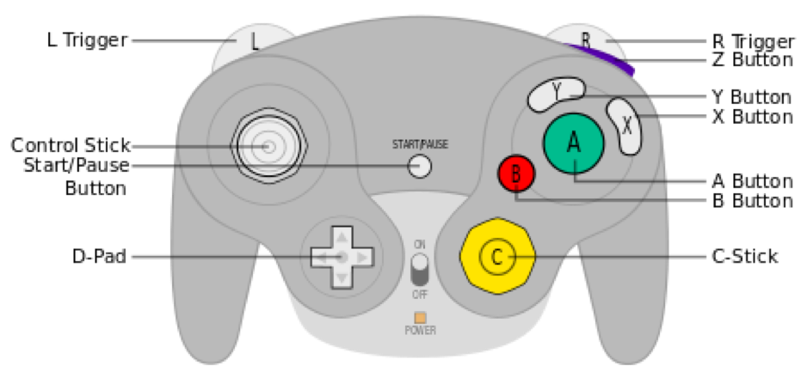

**Figure 1: Game Cube Controller**

Don't worry. Figure 1, above, isn't nearly as confusing as it initially looks. We don't often use all of these buttons anyway. To help guide you is Table 1, an outline of what every button does.

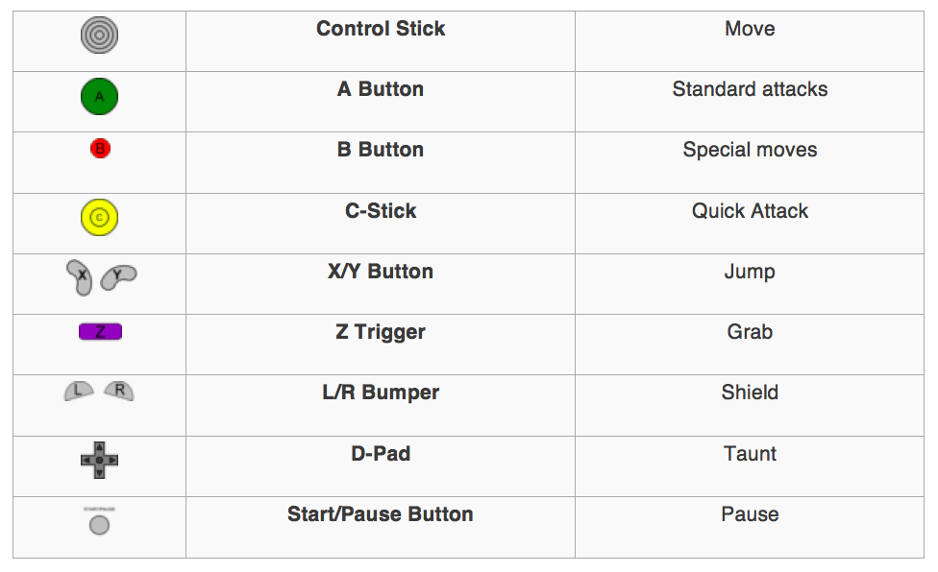

**Table 1: Controller Features and Actions**

Each character is different, but they all are controlled by this set of buttons. Rather than introducing each character, we will explain the basic set of instructions that will allow you to play with any character. We will use Mario, a common character, to show all of the moves we describe.

**Step 1: Moving and Jumping**

1. To move left and right you simply tilt the Control Stick horizontally in either direction. The joystick is sensitive, so if you press all the way to either side, your character will run or "dash". This movement is shown in Figure 2 below. There are three total left-right movement speeds, all which depend on how far you tilt the joystick. You can also crouch by tilting downwards.



**Figure 2: Mario Character Performing a Dash**

1. To jump, simply tilt the Control Stick upwards. Jumping can also be achieved by pressing either the X or Y buttons. A simple single jump is shown in Figure 3. Double jumping can be achieved by "jumping" again while your character is in mid-air. Either the tilting movement or button-press will work, though most find a button press to be easier.



**Figure 3: Mario Character Performing a Single Jump**

**Step 2: "A" Attacks (Neutral Attacks)**

***Basic Attack:*** Simple. Press “A”. The “A” button causes your character to execute a simple forward-facing jab. Multiple presses of “A” quickly will cause your character to do an array of “A” attacks. This move is depicted in Figure 4.1. Additionally, if you jump and press “A”, your character will perform a simple in-air attack.

***Dash Attack:*** To start, make your character to run by tilting strongly left or right. While your character is running, press “A”. Your character will then perform a simple moving attack in the direction you are running. Figure 4.2, below, shows this move.

***Directional Attack:*** To attack, without moving, in a particular direction slowly tilt the Control Stick in any direction. Holding the tilt, press “A”. You can perform the same directional attack in mid-air by jumping beforehand. This attack is also known as a tilt attack. Mario's downward tilt attack is shown in Figure 4.3.

***Smash Attack:*** Without moving, press “A” and, at the same time, firmly tilt the Control Stick up, down, left, or right. The up and down smash attacks differ from the lateral smash attacks. You can also charge your smash attack by holding “A”. An uncharged version of a smash attack is shown in Figure 4.4.



**Figure 4.1: Mario's Array of A Attacks  Figure 4.2: Mario's Rightward Dash Attack**



**Figure 4.3: Mario's Down Tilt Attack  Figure 4.4: Mario's Right Smash Attack**

**Step 3: "B" Attacks**

“B” attacks are special maneuvers. They are the same both on the ground and in the air. Each character has 4 different B-type moves…

***B + Up:*** This is a character’s third jump. By pressing B and, at the same time, tilting the Control Stick upwards, your character will have an extended upwards jump attack. Note: The controls are not jumping and then pressing B. The two must be done at the same time. This is also a damage-causing move for many characters. Mario's B + Up, shown in Figure 5.1, is both a jump and an attack.

***B + Down:*** This move varies across characters, but in each case it often is a gimmick move that absorbs or reflects others’ attacks. Most can also be used as attacks by themselves. These attacks can be implemented by pressing “B” and tilting down simultaneously. Figure 5.2 shows Mario's B + Down attack.

***B + Left/Right:*** These attacks are directed B attacks. Often the left and right “B” attacks are reflectors or movement attacks that move the character across the part of stage. However, not all characters' attacks have movement or reflectors. Like the previous two B attacks, these are achieved by pressing “B” and tilting left or right at the same time. Mario's B + Left/Right attack is a reflector, shown in Figure 5.3.

* ***B:*** Pressing B alone also serves as an attack. These attacks are commonly ranged attacks, such as a shooting a blaster or throwing fireballs, as in Figure 5.4. Again, not all characters have ranged attacks, so the “B” standalone attack also differs from character to character.



**Figure 5.1: Mario's B + Up Jump  Figure 5.2: Mario's B + Down Attack**



**Figure 5.3: Mario's B + Right Attack  Figure 5.4: Mario's B Attack**

**Step 4: Shielding and Dodging**

To shield your character press and hold the “L” or ‘R” bumper. Be careful, however, because your shield does not last indefinitely. If you hold it for too long it will burst and render your character immobile for several seconds. You can tell how much shield you have left by the size of the bubble that covers you. Depictions of a shield and a shield breaking are shown in Figures 6.1 and 6.2, respectively.

Rolling is a dodging maneuver that you can do by holding “L” or “R” and tilting your Control Stick left or right, as shown in Figure 6.3. This allows you to move out of the way of oncoming attacks or opponents without gaining damage. Tilting down while shielding will cause you to spot-dodge, without moving.

You can also dodge in the air by pressing “L” or “R” while jumping or falling. However, dodging disables you from doing other moves (such as recovery moves like jumping), and you’ll only be able to attack once you’ve hit the ground. A neutral air dodge is shown below, in Figure 6.4.



**Figure 6.1: Mario Performing a Shield  Figure 6.2: Mario's Broken Shield Reaction**



**Figure 6.3: Mario's Rolling Dodge  Figure 6.4: Mario's Neutral Air Dodge**

**Step 5: Grabbing and Throwing**

The “Z” trigger is your grab. If you’re within range, facing towards an opponent, and press “Z” you will grab them. Figure 7.1 shows Mario's grab animation with hitboxes. (You don't need to know about hitboxes until later in the game.)

Grabbing does minimal damage on its own, but can be more powerful when combined with pressing “A” and/or tilting to throw the character.

Once you’ve grabbed an opponent, press “A” to hit the opponent a few times before your grab wears out. You can do this before throwing them to maximize damage. You can throw your opponent by tilting up, left, right, or down. Down tilt throws are often used in combo movements, joining them quickly with other attacks. Figure 7.2 shows a left tilt throw by the character Fox against the character Bowser. In Figure 7.3 , the character Kirby grabs and forward throws Mario.

Lastly, you can also grab by shielding (Pressing the “L” or “R” Bumpers) while facing a character, and then pressing “A”. Again, grabbing only works if your opponent is within range.

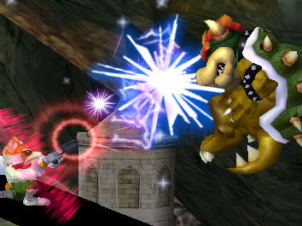

**Figure 7.1: Mario Performing a Grab  Figure 7.2: Fox throwing Bowser**



**Figure 7.3: Kirby Forward Throwing Mario**

**Step 6: C-Stick**

The C-stick is your quick attack. The C-stick is a new control, not part of the original N64 game. These quick attacks are the same as your smash attacks, but are faster and do less damage.

To use the C-stick for attacks, simply press the C-stick in any direction. Your character will then perform a directional quick attack. Figure 8 shows Mario's Up C-stick attack.



**Figure 8: Mario Character Performing an Upwards C-Stick Attack**

**Conclusion:**

If you’ve gotten this far, you now have a basic grasp on how to move, attack, and defend yourself in SSBM. From here you should choose a character to get good with (if you haven’t already). You don’t have to limit yourself to one character, either! Characters in SSBM vary primarily in speed and strength, so test out several different types before settling on the ones you like.

Remember, this guide is by no means comprehensive. You should practice, play with friends, and maybe even research skills if you want to “level up” your abilities. Tournament SSBM games are a great way to test yourself against other people. Tournament play also introduces you to different styles of gameplay and different playing techniques.

We hope that you enjoyed this guide, and that it at least piqued your interest! Check out our second guide, “Level Up: SSBM Subtleties“, which introduces you to some of the more advanced techniques used by SSBM pros!



**Thanks for reading, and happy gaming!**